Master Functional Document

Application | NGERP - Centra
Service Bundle | Master Management
Service Request | Group Credit Limit

Description :

Group Credit Limit master is used to group partner by to a credit limit. This is done with the help of contract no.

Workflow Process :

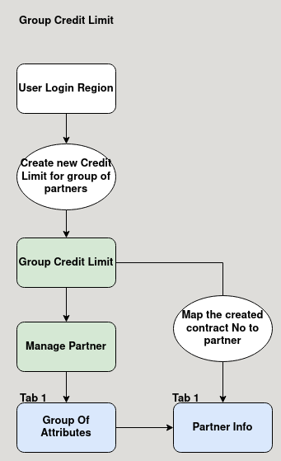

Business Rules :

- User should login as region to create a credit limit group.
- Create a contract number with the credit limit.
- Contract number can be mapped with AR trade partner in the partner info tab.
- Contract number can be mapped with multiple AR trade partner.
- When any one partner sales order is above credit limit, the credit limit error will show for all other partner.

